**CT303 – Digital Communication**

**Lab Exercise 4**

Priya Tank – 202101463

18th October, 2023

Group 5

Question1:

(a) Problem 4.17 and 4.24

Code for problem 4.17:

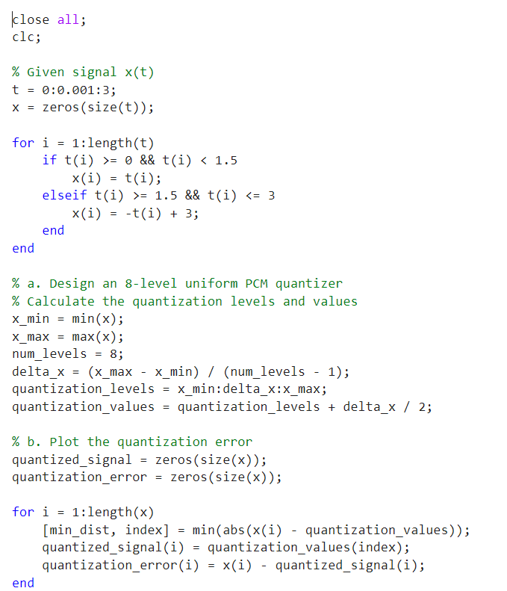

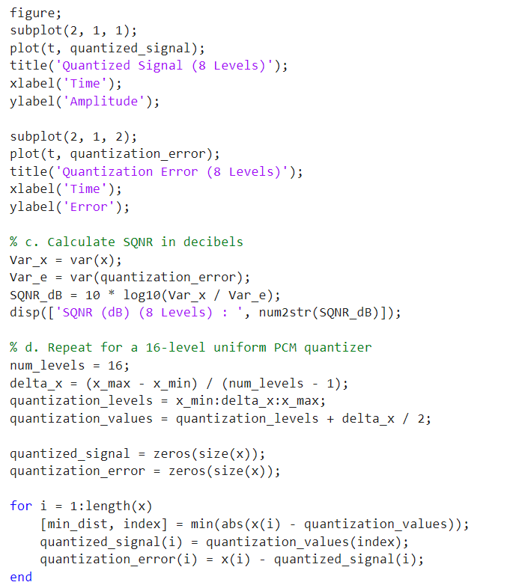

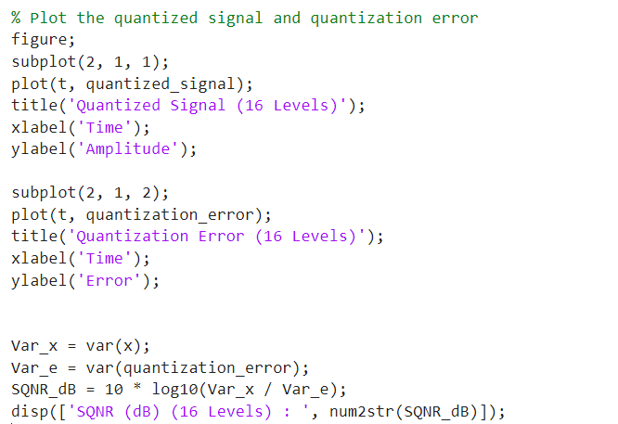

Graph:



For 8 levels:

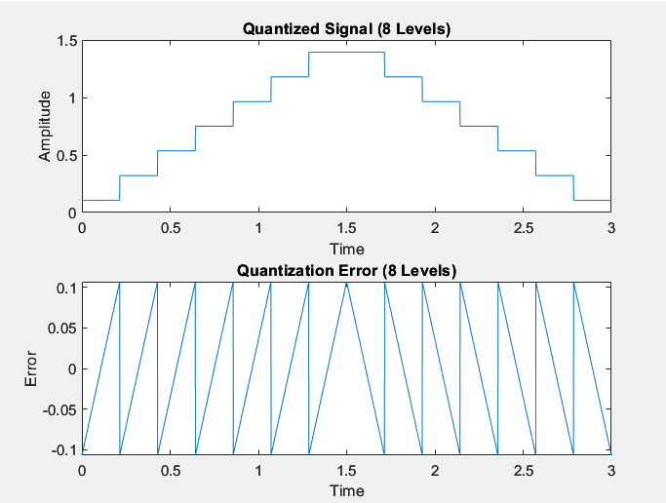

For 16 levels:

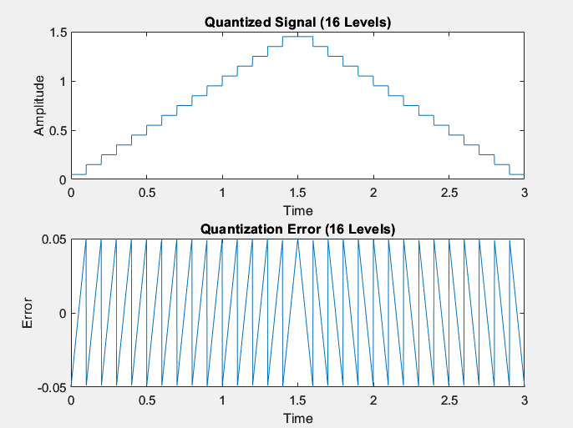

Code for problem 4.24:

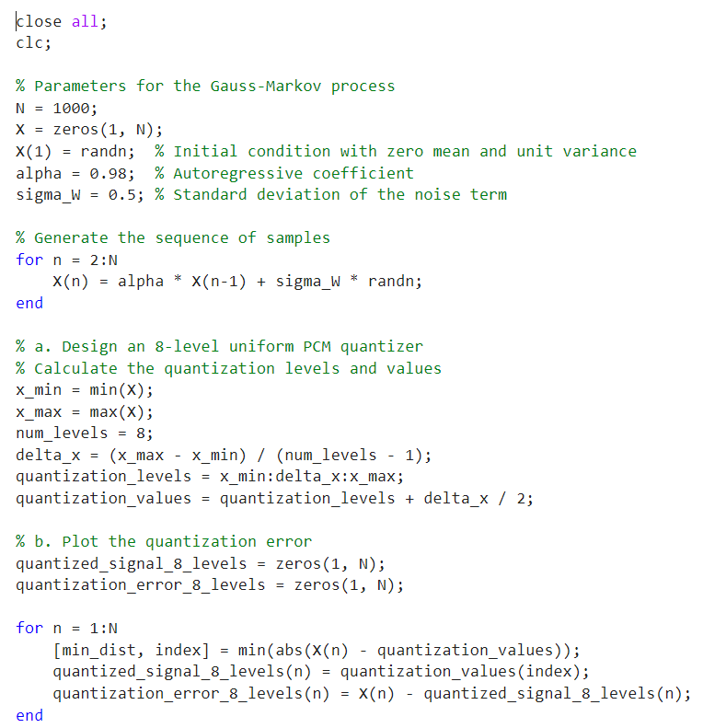

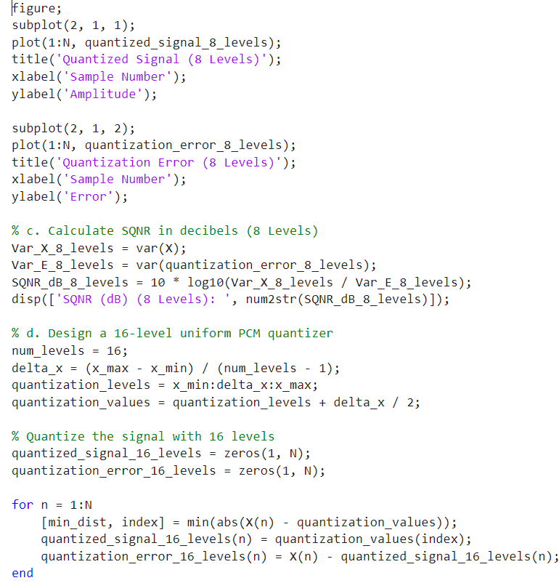

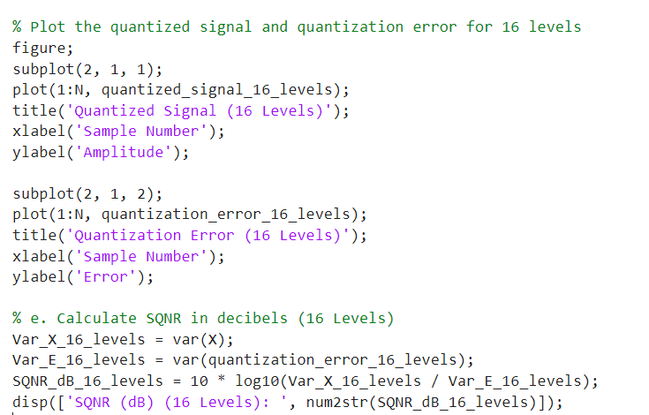

Graph:



For 8 levels:

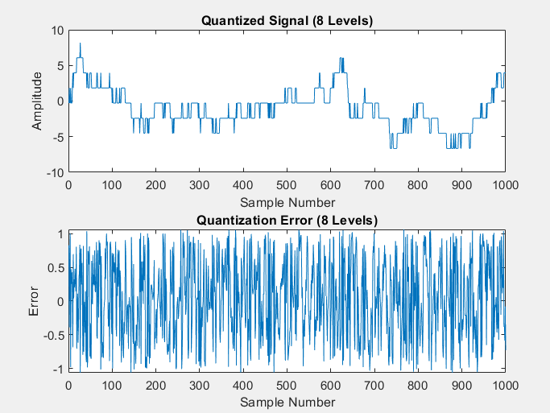

For 16 levels:

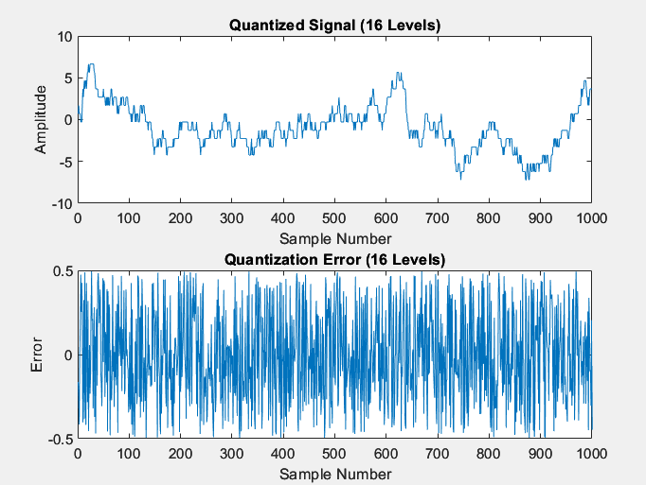

(b) Problem 4.18 and 4.21

Code for problem 4.18:

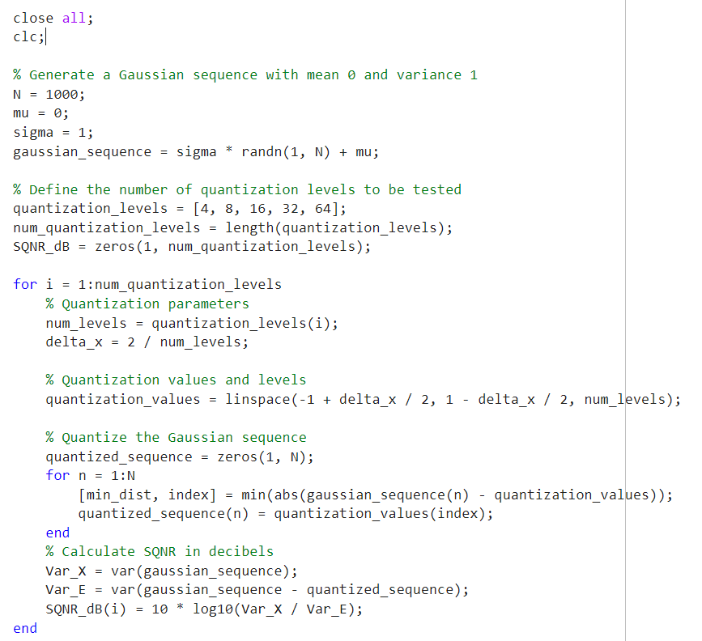

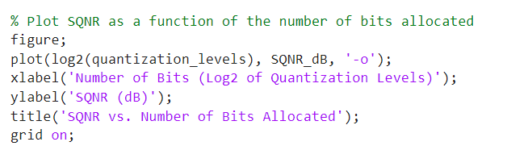

Graph:

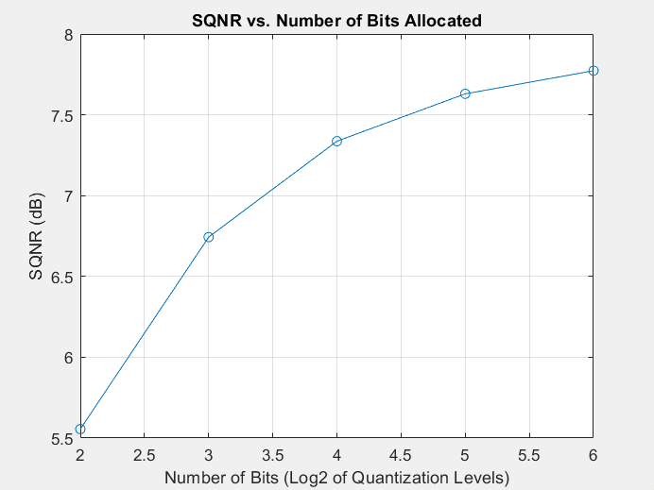

Code for problem 4.21:

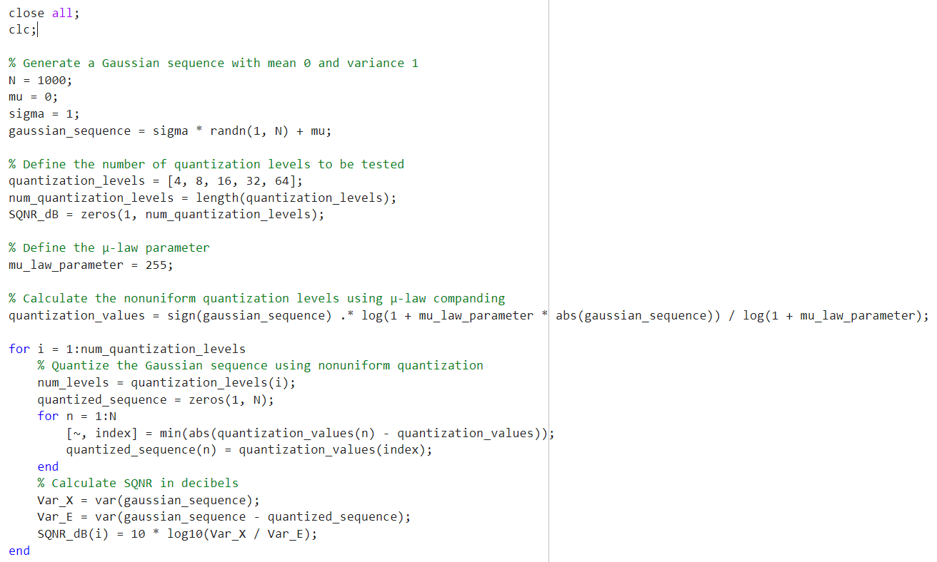

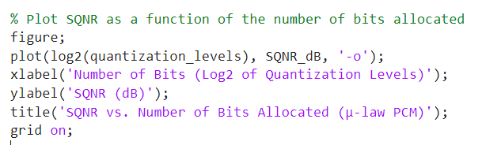

Graph:

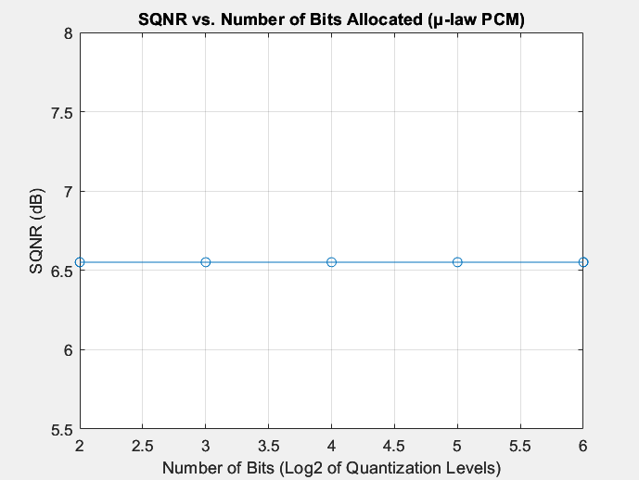

Question2: Plot the quantization error and determine the corresponding SQNR. For the predictor, you can use the normalized LMS algorithm defined by the three consecutive equations in problem 3.40.

Code:

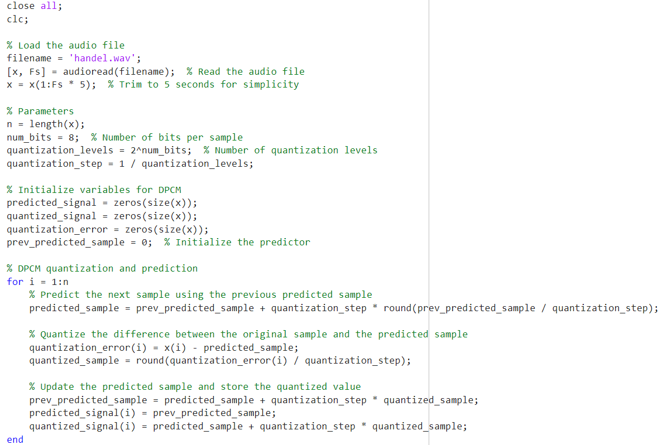

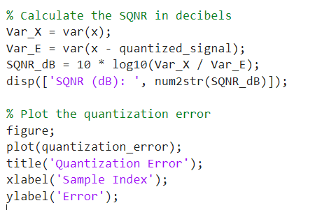

Graph:



